Note¹: All labs are mandatory and you will be marked on 4, randomly chosen out of 12 labs. These will account for 20% of your overall mark (5% each).
Note^{2:}: If a marker requests for a specific lab (e.g. Lab 3) and you do not have Lab 3 available, you can ask for another lab to be marked (e.g. Lab 2) but the total marks for Lab 2 will be reduced by 50%.
Note³: All the labs should be created on one single document following the provided template, saved in your drive (or computer) and accessible anytime. Labs are individual works and they will be submitted into Moodle dropbox - see deadline.
Note⁴: If a LAB is not finished in the scheduled session you should complete it at your most convenient time by the beginning of the next session.
Note⁵: Use a code editor and do not type into VM directly
Online syntax and technical documentations: https://devdocs.io/

LAB 5

- The below SQL statement has five syntax errors. Can you identify them? What would be the correct statement to return exactly the same result as in Fig1? Write the correct SQL statement.

SELECT
movie_id AS "Movie ID",
movie_title AS Movie_Title
movie_lang AS 'LANGUAGE',
cat_name AS "Category"
FROM
movie
INNER JOIN category LINK movie.movie_id = category.movie_id
WHERE
movie_title = ALADDIN CALENDAR
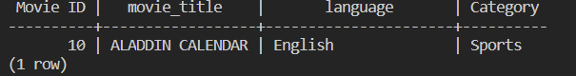
Fig1.

SELECT
movie_id AS "Movie ID",
movie_title AS "Movie_Title",
movie_lang AS "LANGUAGE",
cat_name AS "Category"
FROM
movie
INNER JOIN category ON movie.movie_id = category.movie_id
WHERE
movie_title = 'ALADDIN CALENDAR';

- You are given the following two queries. The table employee has numerous attributes and your department needs the name, NIN and hire date of an employee. Which one will have a better performance and why?
Write down a reasonable explanation.

SELECT
*
FROM
employee
WHERE
employee_id = 1;
SELECT
emp_name,
emp_last_name,
emp_nin,
emp_hire_date
from
employee
WHERE
employee_id =1;
A
B

--query 2 will perform better as you are choosing the specific fields of information you want rather than all of the data associated with that employee

From this point forward we will install and use a new database (Movie Rental). This database will be your main DB for the rest of the module hence it is mandatory to install it for this and future labs. Please follow these instructions on how to install the database. The full ERD (or you can find it on Moodle) and an Interactive Data Dictionary.

DO NOT COPY/PASTE THE SQL STATEMENT AS WILL TAKE OVER 2 HOURS TO INSTALL IT (... yes I have counted). USE SERVER-SIDE COMMAND LINE(s) TO INSTALL IN 20-30 SECONDS.

- Using DB specific commands (consult devdocs), How many VIEWS are inside of the movie_rental database?
SELECT COUNT(*)
FROM information_schema.views
WHERE table_schema NOT IN ('pg_catalog', 'information_schema');

- Using the provided ERD and Data Dictionary, create a query that will return all the movie titles that are in the Documentary category.
Create 2 versions of the same query and in one use category as string (‘documentary’) and in the other use category ID (you will need to check what is the category ID for Documentary).
Use the EXPLAIN ANALYZE command and see which query performs better? Why?
Note: More information about analysing queries you can find here.
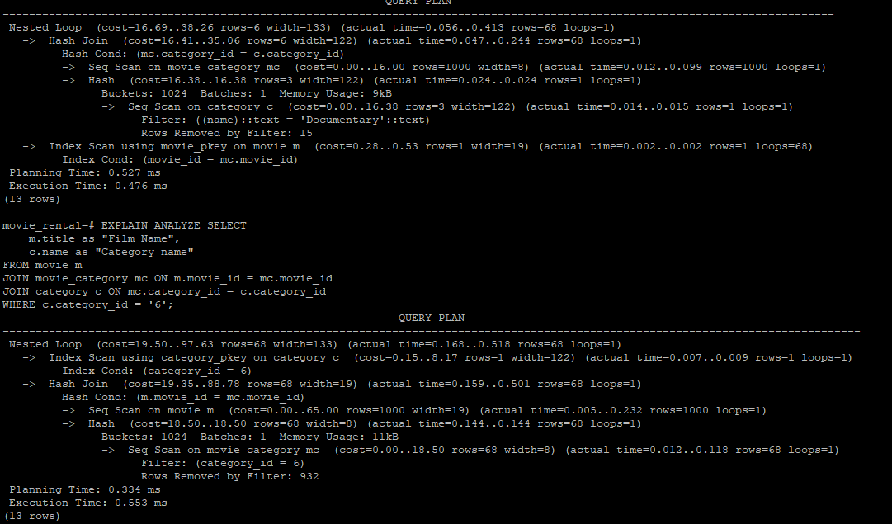

- Using your SQL knowledge create a query that will list all movies that have original language Italian along with the release year. The movies should be listed by release year in chronological order.
SELECT
m.title as "Film Title",
m.release_year as "Release Year"
FROM movie m
JOIN language l ON m.language_id = l.language_id
WHERE original_language_id = '2'
ORDER BY release_year ASC;

- List how many movies are in each category per original language. The output should be similar to the one below.
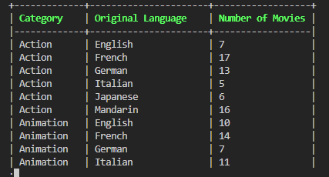

--Q6. List how many movies are in each category per original language. The output should be similar to the one below.

SELECT
c.name AS "Category Name",
l.name AS "Language",
COUNT(m.movie_id) AS "Number of Movies"
FROM movie m
JOIN movie_category mc ON m.movie_id = mc.movie_id
JOIN category c ON mc.category_id = c.category_id
JOIN language l ON m.original_language_id = l.language_id
GROUP BY c.name, l.name
ORDER BY c.name, l.name;

